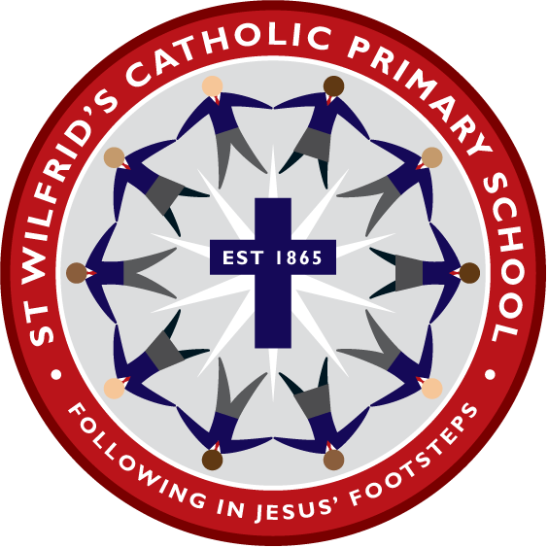

St Wilfrid’s Catholic Primary School
RE, Liturgy and Prayer Policy

Academic Year | Designated Senior Person | Deputy Designated Senior Person | Nominated Governor | Chair of Governors
2014-2015 | A Weir | A Roberts | E Morrissey | E Morrissey
2015-2016 | A Weir | A Roberts | T McGough | E Morrissey
2016-2017 | A Weir | A Roberts | T McGough | E Morrissey
2017-2018 | A Weir | J McEniff | T McGough | E Morrissey
2022-2023 | J McEniff | P Harkness | E Morrissey | E Morrissey

Policy Review Dates

Review Date | Changes made | By whom | Date ratified at FGB
March 2016 | Yes | RE Coordinator | March 2016
November 2017 | Yes | RE Coordinator | To be ratified March 2018
September 2019 |  |  | November 2019
September 2022 | Yes | RE Coordinators

St. Wilfrid’s Mission Statement

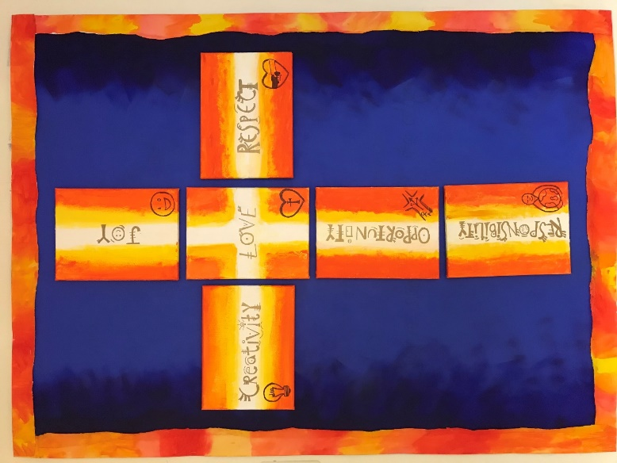
"I have come that they may have life and have it to the full"
John 10:10

At St. Wilfrid’s we love one another,
show respect and accept responsibility.
Embracing opportunity and nurturing creativity,
we share in the joy of Jesus.

St Wilfrid’s Liturgy and Prayer Policy

We believe that Liturgy and Prayer in a Catholic school celebrates God’s presence in our lives and is concerned with giving glory, honour, praise and thanks to God. It is our loving response, in word and action, to God’s invitation to enter into a relationship, made possible through the work of Jesus Christ and the witness of the Holy Spirit.

As a Catholic school, we are fully committed to providing opportunities for all children to know, love and serve God, in such a way that will enrich their own lives and help them to understand their Catholic faith traditions, in an ever- changing world and within the multicultural society in which they live.

To this effect, we believe that Liturgy and Prayer in our school aims to provide opportunity for all children and staff:
- To contemplate something of the mystery of God
- To reflect on spiritual and moral issues
- To explore their own beliefs
- To respond to and celebrate life
- To experience a sense of belonging and develop community spirit
- To develop a positive attitude to those of other cultures and faiths
- To develop a common ethos and shared values
- To enrich religious experience
- To grow in liturgical understanding and development
- To reinforce prayers which are part of the Catholic tradition
- To participate fully
- To take time to grow close to God in the stillness of His presence.
- To take to develop a sense of ‘awe and wonder’

We support and acknowledge the fact that prayer, liturgy and assembly are distinct activities. They may sometimes form part of the same gathering, but the difference between the these will always be made clear.

Prayer and liturgy is separate to the designated curriculum time under regulations and will not be subsumed under any part of the curriculum, including Religious Education.

Liturgy and Prayer is generally organised as follows:

Monday Gospel Assembly for KS2 (am)
Gospel Assembly for EYFS and KS1 (pm)
Tuesday Classroom teacher/child-led prayer
Wednesday Wednesday Word – school values assembly
Thursday Classroom teacher/child-led prayer
Friday Whole school celebration assembly/class assemblies
Daily Class prayers
Regularly Hymn practice, whole school Masses

Mass is celebrated regularly including to mark the start and end of the school year, on the Feast of St. Wilfrid as well at significant points in the Liturgical year.

Advent liturgies and penitential services take place during the Season of Advent.

A Carol service is held at St.Wilfrid’s Church for the whole school and families.

Christmas Nativities take place involving Pre-School and Reception and KS1

Special events take place in October and May to honour Mary, our Mother.

Penitential services are held during Lent.

Holy Week in school focuses on The Way of the Cross with class and whole school opportunities to reflect on the events of Holy Week. The week concludes with the celebration of Holy Mass.

Morning prayers are said in classrooms as well as prayers before and after lunch and at the end of the day. We also provide the opportunities and resources for teacher and children to plan and lead their own classroom prayer services. These classroom services are known as Liturgical Prayer services.

Parish-led Sacramental programmes are in place and support is offered.

Through this and all that we do, we continue to foster and deepen the staff and children’s personal relationship with God. Liturgy and Prayer at St Wilfrid’s is more than just a legal requirement it is an integral part of school life and central to the Catholic tradition.

St Wilfrids Religious Education Policy

Philosophy

Religious Education plays a vital and central part in a Catholic school. At the heart of Catholic Education lies the Christian vision of the human person.
Our faith, the Mass and a love of the sacraments is the foundation of our teaching.

We seek to enable each child to experience that faith in action, as members of a caring community, and walk with them on their journey through life.

Each child is recognised as unique, a child of God, with individual needs which we accommodate in our teaching and organisation.
To provide a broad, balanced, relevant curriculum and to help each individual to achieve their full potential. To make learning fun. We try to live out our Mission Statement and school values daily and through our teaching and example we aim to enhance the Spiritual and Moral development of our children as young, Catholic Christians.

Aims:
- To foster a love of God through Knowledge and Understanding of the Catholic faith from Scripture and doctrine.
- Through experience of prayer to encourage a personal relationship with God.
- To develop respect for truth and for the views of others
- To help our children to be aware of and respect other faiths.
- To develop reflection, thinking and listening skills.
- To encourage our children to study, investigate and reflect.

Home/School/Parish partnership

St Wilfrid’s relies on links with the home and our three parishes to enrich the lives of our children in their faith.

Our Parish Priest takes an active part in school life through regular visits. The link between school, home and parish is particularly visible in sacramental preparation.

St Wilfrid’s supports many charities locally, nationally and internationally with particular commitments to CAFOD and the Good Shepherd Fund.

The school website also offers parents an insight into their child’s education, where they can view photographs and information about a range of activities their child have taken part in.

Equal Opportunities and Inclusion

A central message of the Catholic Faith is that although we are all different, God loves each one of us equally, regardless of background, gender or ability. It is therefore vital that we recognise and cater for the individual needs of children, acknowledging that all children have different talents and gifts and that these should be celebrated.

We recognise the importance of presenting topics and activities enabling them to achieve success, helping them to develop their full potential and develop a positive self image.

RE Curriculum: organisation

St Wilfrid’s follows the Religious Education programme “The Way, The Truth and The Life” as adopted by the Shrewsbury Diocese. This is an annual cycle of topics which are particular to each year group; two topics are studied each term, each topic lasting approximately six weeks. (See Appendix 1)

RE lessons constitute 10% of curriculum time in all key stages. This equates to KS1 (2hours) and KS2 (2 ½ hours).

Time is also given to class and whole school liturgies/assemblies and for classroom prayer time.

Through ‘The Way, The Truth and The Life’ children will:

- Explore the religious dimensions about life, dignity and purpose within the Catholic Tradition.
- Begin with and reflect on their own experiences
- Make links with other faith traditions
- Gain knowledge of the Old and New Testament as the Word of God.
- Be helped to recognise their own vocation as members of a joyful Christian community.

Other Faiths

We aim to develop the children’s knowledge and understanding of other faiths and a willingness to empathise with people who hold beliefs that are different to our own. We help the children to learn from religions as well as about religions.

At St Wilfrid’s, it has been decided that we will study Judaism and Islam through an annual themed week, alternating each year.
These faiths have been chosen because of their close links to Christianity. Should a pupil of another world faith be admitted to our school, then this faith would also be included, if appropriate.

Assessment
We recognise that assessment, recording and reporting are a natural part of teaching and integral to the learning process but it is impossible to assess the level of a child’s personal faith and it should not be attempted. However, we are able to assess the child’s knowledge, skills, concepts and attitudes which have been taught in RE.

Each year group assesses three topics each year in line with the diocese. One year it will be topics 1, 3 and 5 and the following year topics 2,4 and 6.

The assessment of standards is carried out using the criteria set out in the Levels of Attainment booklet agreed by the Bishops’ Conference.

Teachers continually make assessments using strategies such as:
- Looking at Children’s recorded work and marking.
- Teacher observations of children during role play, carpet time etc.
- Speaking and listening contributions during lessons.
- Discrete observations during prayer circle time.

There will be one formal assessment of children’s work per term.
The formal assessment for each term.
A sample of work each term, covering a range of abilities will also be given to the subject leader to form part of the school portfolio.
Teachers will meet twice a year to moderate work together.

Progress and achievement in Religious Education is reported to parents/carers in a written report at the end of each academic year

Attainment Targets and Strands
Attainment Target 1 (AT1) is learning ABOUT Religion.
Attainment Target 2 (AT2) is learning FROM Religion (No longer formally assessed)
In AT1 these are:
AT1i beliefs, teachings and sources
AT1ii celebration and ritual
AT1iii social and moral practices and way of life

Marking is approached positively and constructively so that it affirms and celebrates success and encourages future learning.

Monitoring of teaching and learning

In order to monitor the teaching and learning of Religious Education, at least one formal lesson observation or learning walk per year is carried out by the subject leader or the Head Teacher.
A Book look is also carried out regularly by the subject leader or SLT/ RE Governor.
Planned ‘Pupil voice’ discussions with pupils are also carried out annually.

Prayer Focus and displays

Classroom Prayer focus will relate to the WTL topic being studied to stimulate and facilitate reflection and prayer, linked with the topic and Liturgical season.

Resources

Each class has the relevant resources for The Way, The Truth and The Life, a copy of Church Story and God’s Story.

Bibles appropriate to each age group are kept in the class rooms.

Artefacts, icons, statues, candles etc. are also placed strategically around the school.

Articles of Faith and other resources are stored in the Chapel cupboard and are accessible to all staff .

Management of the subject
Mrs Lyndsey Bold and Mrs Lara Cannavan, Subject Leaders have responsibility for leading, managing and supporting the delivery of and training in Religious Education and Liturgy and Prayer. (See Appendix 2)

Appendix 1

Curriculum Overview

Overview of Foundation and Key Stage One Syllabus

 | Autumn 1 | Autumn 2 | Spring 1 | Spring 1 | Summer 1 | Summer 2
Foundation | F1  God’s World | F2  God’s Family | F3  Getting to know Jesus | F4  Sorrow & Joy | F5  New Life | F6  Church
Year 1 | 1.1  God’s  Great  Plan | 1.2  Mary,  Mother of  God | 1.3  Families &  Celebrations | 1.4  Following  Jesus | 1.5  Resurrection | 1.6  Miracle
Year 2 | 2.1  Chosen  People | 2.1  Chosen  People | 2.3  The Good  News | 2.4  The Mass | 2.5  Eastertide | 2.6  Birth of the  Church

Overview of Key Stage 2 syllabus

 | Autumn 1 | Autumn 2 | Spring 1 | Spring 1 | Summer 1 | Summer 2
Year 3 | 3.1  The  Christian  Family | 3.2  Mary, Our  Mother | 3.3  Called to  change | 3.4  Eucharist | 3.5  Celebrating  Easter &  Pentecost | 3.6  Being a  Christian
Year 4 | 4.1  The Bible | 4.2  Trust in God | 4.3  Jesus, the  Teacher | 4.4  Jesus, the  Saviour | 4.5  The Mission  of the  Church | 4.6  Belonging to  the Church
Year 5 | 5.1  Gifts from  God | 5.2  The  Commandments | 5.3  Inspirational  People | 5.4  Reconciliation | 5.5  Life in the  Risen  Jesus | 5.6  People of  Other Faiths
Year 6 | 6.1  The  Kingdom  of God | 6.2  Justice | 6.3  Jesus, the  Bread of Life | 6.4  Jesus, Son of  God | 6.5  The Work  of the  Apostles | 6.6  Called to serve

Appendix 2

The Role of the Co-ordinator for Religious Education

The Religious Education Co-ordinator will be responsible for:
- Working with senior leaders on monitoring teaching and learning, planning and standards through lesson observations and work scrutinises according to school practice.

- Organising and maintaining the school portfolio of pupils’ work.

- Organising in-house moderation of standards meetings.

- Self evaluation to identify strengths and areas for development.

- Ensuring the curriculum offered is appropriate, suitable and relevant to pupils’ needs and interests.

- Attending appropriate training and keeping up to date with current thinking, policy and developments and feeding back to staff.

- Organising and leading in-house staff training and development.

- Identifying training needs of staff to ensure their suitability to teach effective Religious Education.

- Supporting and advising colleagues in the delivery of Religious Education.

- Liaising with the Headteacher, Governors, parents, the Office for Education & Schools on matters relating to Religious Education.

- Auditing, managing and developing resources within a given budget.

