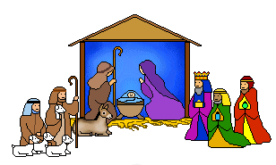
December2024

Dear Parents and Carers,

I am writing this Christmas letter as the third candle on St Wilfrid’s School Advent wreath representing “Joy” has been lit, and inevitably our minds will start to turn from the day to day school life, to the festive period of Christmas and the coming of our Saviour Jesus Christ. The prospect of the Christmas season most certainly cheers and lifts our spirits away from the cold, dark seasonal weather. The festive atmosphere throughout the school is a testament to the dedication and creativity of all the staff and children. The decorations in the classrooms reflect the joy and anticipation that this special time of the year brings.

This term there have been many achievements, both in and out of the classroom. The enthusiasm of all the children to their learning is wonderful to see in action within the school day. However, staff are also mindful that children’s learning needs to be encouraged and nurtured so that all children will develop; to help them grow into good citizens. The children’s behaviour this term in and around school has been amazing. Their care of each other and concern for their wider community is a credit not only to the school, but also to you as Parents and Carers. So, on behalf the Governing Body I would like to take this opportunity to say “Thank You” for all that each one of you does to support St Wilfrid’s School Community it is very much appreciated.
The Governing Body have discussed and looked at a number of areas across the school these include during this term:
- Safeguarding Procedures and Practices
- Curriculum
- RE
- Data
- SEND
- Budget
- Ratifying Policies
All the above areas will be kept under review throughout the rest of the academic year and we know as a Governing Body additional areas will most certainly be added as they become evident. As a school we as Governors are never complacent; we all openly reflect on our work to date, we then set challenging next steps targets, we do this with the sole aim of bringing to reality our collective vision of enabling both staff and children within our school community to fulfil their potential. The work as the say never stops but continues.
I know that you would all wish to join with me and the governing body as I say

“Thank You” to Mrs McEniff, All the Senior Leadership Team as well as all of the Teachers, Support staff, Office staff , Site Manager, Kitchen/ Cleaning Team, EBNOC and the Pre-school for all their hard work during this last term. It has been a long and challenging term but I know a very worthwhile term. Your total commitment to the children, not only in daily school life but in providing many additional experiences shows the dedication to St Wilfrid’s School. The Governing Body are very blessed to have you all working with the children.
We are also very fortunate in having a very small but extremely dedicated band of Parents who form St Wilfrid’s PTFA and this small group work very hard to provide the very much appreciated extra’s for the children. This small group all give their time freely and so on behalf of the whole school community “Thank You” to each one of you
“Thank You” to all our volunteers who support both teaching and non-teaching staff within the school. We must always remember that they also give their time to help staff in a variety of roles to support the children’s learning.

As Chair of Governor’s, I want to say to all our wonderful children for their hard work throughout this term. It has been a privilege to see the children learning new concepts from an ever-challenging curriculum and making progress throughout the term. They have enjoyed the different topics and it has been wonderful to see them engaged and enthused in lessons and their excitement when they are involved with new experiences. They continue to develop as learners and understand that a growth mind-set helps them to achieve their hopes, wishes and dreams. Each and every child has contributed to the school’s improvement journey and they should all feel very proud of their achievements.
Finally, can I take this opportunity to say a huge “Thank You” to the Governing Body for their commitment and support that each one of you have given this term. All of our Governors at St Wilfrid’s School are all volunteers who all work tirelessly to ensure that our school is the best that it can possibly be for the whole school family.
So, as Christmas approaches, the Governors wish you and your families the gladness of Christmas, which is Hope, the spirit of Christmas, which is Peace and the heart of Christmas which is Love.
And this Christmas I pray:
Loving God
During this holy season of Christmas, I ask for your blessings on all our families,
Let Mary’s openess to your wonderous ways be an inspiration to place all trust in you.
Let Joseph’s courage provide hope during times of anxiety and uncertainty.
Let Jesus’ life ignite all our families with a spirit pf light and love.
May the grace that encircles the Holy Family widen to embrace all our families.
Amen
And I wish you and all your families
“A very Happy and Holy Christmas and a Peaceful New Year”
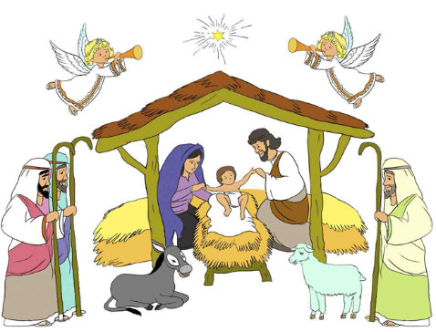
God bless
Mrs Morrissey
Chair of Governors

.

