

|  |
| --- |
| **St Wilfrid’s Catholic Primary School Anti Bullying Policy** |

|  |  |  |  |  |
| --- | --- | --- | --- | --- |
| **Academic Year** | **Designated Senior Person** | **Deputy Designated Senior Person** | **Nominated Governor** | **Chair of Governors** |
| 2014-2015 | A Weir | A Roberts | E Morrissey | E Morrissey |
| 2015-2016 | A Weir | A Roberts | E Morrissey | E Morrissey |
| 2016-2017 | A Weir | A Roberts | E Morrissey | E Morrissey |
| 2017-2018 | A Weir | J McEniff | E Morrissey | E Morrissey |
| 2018-2019 | A Weir | J McEniff | E Morrissey | E Morrissey |
| 2019-2020 | A Weir | J McEniff | E Morrissey | E Morrissey |
| 2020-2021 | J McEniff | P O’Hara | E Morrissey | E Morrissey |
| 2021-2022 | J McEniff | M Davies / P Harkness | E Morrissey | E Morrissey |
| 2022-2023 | J McEniff | P Harkness | E Morrissey | E Morrissey |
| 2023-2024 | J McEniff | P Harkness | E Morrissey | E Morrissey |

Policy Review Dates

|  |  |  |  |
| --- | --- | --- | --- |
| **Review Date** | **Changes made** | **By whom** | **Date ratified at FGB** |
| October 2014 |  | A Weir |  |
| November 2015 |  |  | November 2015 |
| September 2016 |  |  | September 2016 |
| September 2017 |  |  | November 2017 |
| September 2018 |  |  | November 2018 |
| September 2020 | To be reviewed – delayed due to Covid | |  |
| September 2021 |  |  |  |
| September 2022 | Updated CW&C Policy | P.Harkness / JMcEniff | October 2022 |
| October 2023 | Terminology Changes | P.Harkness / JMcEniff | November 2023 |

***MISSION STATEMENT***

*“I have come that they may have life,*

*and have it to the full.”*

*John 10:10*

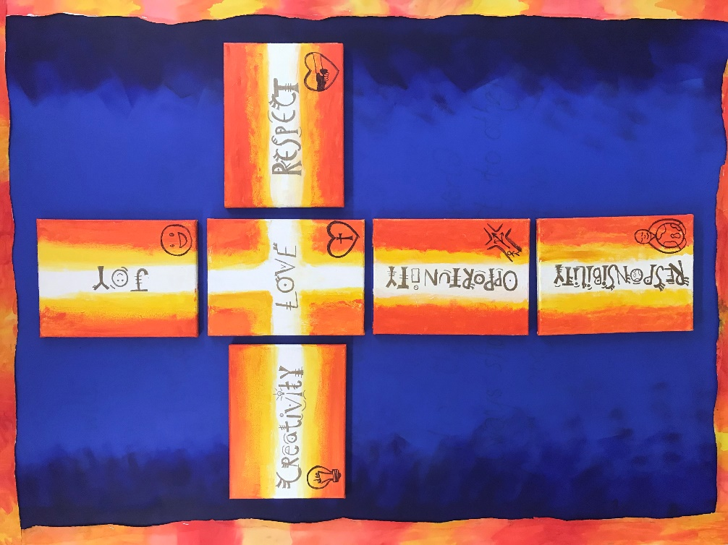

*At St. Wilfrid’s we love one another,*

*show respect and accept responsibility.*

*Embracing opportunity and nurturing creativity*

*we share in the joy of Jesus.*

**Anti-bullying Policy**

**Rationale**

As a Catholic school endeavouring to foster our school and Gospel values, a focus on the quality of relationships is at the heart of the school’s ethos. St Wilfrid’s Catholic Primary School, therefore, has a zero-tolerance attitude to bullying.

The school has a legal duty of care towards pupils and must determine measures with a view to encouraging good behaviour and respect for others on the part of pupils and, in particular, preventing all forms of bullying among pupils.

**Aims**

This policy aims to:

* Promote a secure and happy environment free from threat, harassment and any type of bullying behaviour.
* Ensure all teaching and non-teaching staff, pupils and parents understand what bullying is.
* Inform children and parents of the school’s expectations and to foster a productive partnership, which helps maintain a bully-free environment.
* Show commitment to overcoming bullying by practising zero tolerance.
* Identify and deal with incidents of bullying consistently and effectively.

**Responsibilities**

It is the responsibility of:

* The Headteacher to communicate this policy to the school community, to ensure that disciplinary measures are applied fairly, consistently and reasonably, and that a member of the senior leadership team has been identified to take overall responsibility.
* Governors to take a lead role in monitoring and reviewing this policy.
* All staff, including governors; senior leadership; teaching and support staff; Midday Assistants; site management staff and office staff to support; uphold and implement this policy accordingly.
* Parents/carers to support their children and work in partnership with the school.
* Pupils to understand and follow the policy.

**Bullying**

**What is it?**

The repetitive, intentional hurting of one person or group by another person or group, where the relationship involves an imbalance of power. Bullying can be physical, verbal or psychological. It can happen face-to-face or online.

Bullying can be one or more of the following:

***Emotional*** – being unfriendly, excluding, tormenting, using threatening gestures;

***Physical*** – pushing, kicking, hitting, punching or use of violence;

***Racist*** – Using racial taunts, graffiti, gestures;

***Gender and sexual*** – making unwanted physical, sexual contact or sexually abusive comments because of, or focusing on, the issue of sexuality;

***Verbal*** – name calling, sarcasm, spreading rumours, teasing;

***Disability related*** – name calling, using gestures, tormenting or threatening because of, or focussing on, the issue of disability or special need;

***Online / Cyber*** – all areas of the internet, such as e-mail, instant messaging, social media, gaming and internet chat room misuse, mobile threats by messaging and calls. Misuse of associated technology, i.e. camera and video facilities.

**Hate Crime** - A **hate crime** is when someone breaks a law by hurting another person because of [prejudice](https://kids.kiddle.co/Prejudice) against a group the victim belongs to. Normally, a hate crime is not caused in any way by something the victim did or said, but just because of who they are. People often commit hate crime because of prejudice about the victim's [sex,](https://kids.kiddle.co/Sex) [ethnicity,](https://kids.kiddle.co/Ethnicity) [religion,](https://kids.kiddle.co/Religion) [nationality,](https://kids.kiddle.co/Nationality) [gender identity,](https://kids.kiddle.co/Gender_identity) [class,](https://kids.kiddle.co/Social_class) [sexual orientation](https://kids.kiddle.co/Sexual_orientation)[, age,](https://kids.kiddle.co/Ageing) or other things about them.

This policy is designed to ensure that as a school we are alert to signs of bullying and act promptly and firmly against it.

**What Bullying is not**

It is important to understand that bullying is not falling out with friends on the odd occasion. Children are naturally sociable; it is vital for them to select and build friendships. The forming of and breakdown of friendships is an important part of growing up. When children ‘fall out’, they can say and do things because they are upset. It is essential to teach children the skills to repair relationships and enable them to utilise these. If as adults we intervene too readily to help rebuild our children's friendships on their behalf, our children may not develop the necessary social skills. Occasionally, situations go beyond broken friendships or minor differences, and on these occasions, adult intervention is necessary.

**Prevention**

At St Wilfrid’s we believe that our response to bullying should not start at the point at which a child has been bullied. Our ultimate goal is to educate our children and create a caring, co-operative ethos, free from bullying. We promote an anti-bullying ethos through:

• high-quality PHSE and RE lessons

• our school values of love, joy, respect, responsibility, opportunity and creativity

• whole-school assemblies

The school has a range of strategies in place to help children work and behave cooperatively, in order to minimise the possibility of bullying taking place.

1.Through our PHSE and Computing curriculum we promote the safe and positive use of mobile phones, tablets, games consoles and computing equipment. Both children and parents are made aware of how to use the internet safely and the possibilities of online, cyber bullying.

2.We have regular school assemblies linked to the liturgical calendar, R.E curriculum and our school values

3.St Wilfrid’s has a clear Behaviour Policy that rewards positive behaviour.

4.The school takes a pro-active approach towards challenging behaviour at lunchtime. Staff and children share strategies for resolving conflict to support and scaffold problem solving at playtime. We have equipment and activities available to ensure all children are positively engaged and active at lunchtimes to avoid unwanted behaviour.

5.Lunch time club runs for children who wish to have a quiet space to be at lunch.

6. Lunch time friendship groups are run by our Family Liaison Officer to promote positive relationships and to build self-esteem and confidence

7.Parents are encouraged to talk to staff about any concerns in behaviour they may have.

## **Procedures**

It is recognised that incidents of bullying occur in all schools. Therefore, at St Wilfrid’s, it is essential that all such incidents are taken seriously and dealt with in an appropriate manner. A pupil or parent may report an incident to any member of staff, but the responsibility for ensuring all incidents are consistently dealt with lies with the class teacher.

The class teacher is responsible for recording and tracking all incidents relating to negative behaviours among the children in their care on CPOMS. They are responsible for taking appropriate action to address issues and ensuring that concerns regarding persistent and ongoing behaviours are reported to the headteacher.

All other staff, who become aware of or deal with issues have a responsibility to report incidents to the class teacher of the child (ren) concerned.

The headteacher will be responsible for embedding anti-bullying awareness in the policies and practices of the school and will support staff with issues that are prolonged or have become difficult to manage.

The Governors are responsible for ensuring that the Anti-bullying policy is reviewed annually and that the duties entailed are discharged effectively.

The Local Authority monitor bullying incidents in schools and the school has a duty to report termly on incidents that have occurred in school

The following steps may be taken when dealing with incidents:

* If bullying is suspected or reported, the incident will be dealt with immediately by the member of staff who has been approached.
* The staff member should investigate the alleged bullying by consulting with the young person who has been bullied.
* The staff member should report the incident and how it has been dealt with to the class teacher concerned.
* MDAs should report to staff at the end of lunch
* The member of staff and the class teacher should reach agreement as to whether this incident constitutes bullying or should be addressed as an incident of poor behaviour.
* If it is felt that an incident of bullying has taken place, then it will be taken seriously and investigated.
* If the incident is deemed to be bullying, the class teacher will speak to the pupils involved, including witnesses and bystanders, and proceed accordingly.
* The headteacher will be informed. Such incidents and actions should be raised by the class teacher without delay.
* All incidents should be recorded on CPOMS as soon as is practically possible.
* If the incident is deemed to be bullying, communication with parents is required or if it is a parent raising a concern about bullying, the headteacher will be informed.

## **Monitoring, Evaluation and Review**

The school will review this policy annually and assess its implementation and effectiveness. The review will be reported to the designated Governor for Safeguarding. The revised policy will be promoted and implemented throughout the school

**Appendix 1**

## **Bullying: Signs and Symptoms**

A child may indicate by signs or behaviour that he or she is being bullied. Adults should be aware of these possible signs and that they should investigate if a child:

* is frightened of walking to or from school
* begs to be driven to school
* changes their usual routine
* is unwilling to go to school
* begins to truant
* becomes withdrawn, anxious, or lacking in confidence
* starts stammering
* attempts or threatens self-harm, suicide or runs away
* cries themselves to sleep at night or has nightmares/bedwetting
* regularly feels ill in the morning
* begins to do poorly in school work
* comes home with clothes torn or books damaged
* has possessions which are damaged or go “missing”
* asks for money or starts stealing money (to pay the bully)
* has dinner or other monies continually ‘lost’
* has unexplained cuts or bruises
* comes home very hungry (money/ lunch has been stolen)
* becomes aggressive, disruptive or unreasonable
* becomes unreasonable when dealing with school issues
* is bullying other children or siblings
* stops eating
* is frightened to say what’s wrong
* gives improbable excuses for any of the above
* is afraid to use the internet or mobile phone

**Appendix 2**

## **Help available**

There is a vast amount of information and guidance available about bullying that can provide a wide range of support and help. The following list is just a small selection of the support available that teachers, parents and children have found useful.

## Useful Links and supporting organisations

* Act Against Bullying [www.actagainstbullying.org](http://www.actagainstbullying.org/)
* Advisory Centre for Education (ACE) [www.ace-ed.org.uk](http://www.ace-ed.org.uk/)
* Childline www.childline.org.uk Anti-Bullying Alliance (ABA) [www.antibullyingalliance.org.uk](http://www.antibullyingalliance.org.uk/)
* Anti-bullying Network [www.antibullying.net](http://www.antibullying.net/)
* Bully Free Zone [www.bullyfreezone.co.uk](http://www.bullyfreezone.co.uk/)
* Bullying UK [www.bullying.co.uk](http://www.bullying.co.uk/)
* Bullying Online www.bullying.co.uk Kidscape [www.kidscape.org.uk](http://www.kidscape.org.uk/)
* NSPCC [www.nspcc.org.uk](http://www.nspcc.org.uk/)
* Parentline Plus [www.parentlineplus.org.uk](http://www.parentlineplus.org.uk/)

## SEND

* Changing Faces: [www.changingfaces.org.uk](http://www.changingfaces.org.uk/)
* Mencap: [www.mencap.org.uk](http://www.mencap.org.uk/)
* Anti-Bullying Alliance Cyberbullying and children and young people with SEN and disabilities: [www.cafamily.org.uk/media/750755/cyberbullyingandsend](http://www.cafamily.org.uk/media/750755/cyberbullyingandsend)[modulefinal.pdf](http://www.cafamily.org.uk/media/750755/cyberbullying_and_send_-_module_final.pdf)
* DfE: SEND code of practice:[www.gov.uk/government/publications/sen](http://www.gov.uk/government/publications/sen)[dcode](https://www.gov.uk/government/publications/send-code-of-practice-0-to-25)-[ofpractice-0-to-25](https://www.gov.uk/government/publications/send-code-of-practice-0-to-25)

## Online or Cyberbullying

* Childnet: [www.childnet.com](http://www.childnet.com/)
* Internet Watch Foundation: [www.iwf.org.uk](http://www.iwf.org.uk/)
* Think U Know: [www.thinkuknow.co.uk](http://www.thinkuknow.co.uk/)
* UK Safer Internet Centre: [www.saferinternet.org.uk](http://www.saferinternet.org.uk/)
* The UK Council for Child Internet Safety (UKCCIS) [www.gov.uk/government/groups/uk-](http://www.gov.uk/government/groups/uk-council-for-child-internet-safety-ukccis)

DfE ‘Advice for parents and carers on cyberbullying’:

[www.gov.uk/government/publications/preventing-and-tackling-bullying](http://www.gov.uk/government/publications/preventing-and-tackling-bullying)

## Race, religion and nationality

* Anne Frank Trust: [www.annefrank.org.uk](http://www.annefrank.org.uk/)
* Kick it Out: [www.kickitout.org](http://www.kickitout.org/)
* Report it: [www.report-it.org.uk](http://www.report-it.org.uk/)
* Stop Hate: [www.stophateuk.org](http://www.stophateuk.org/)
* Tell Mama: [www.tellmamauk.org](http://www.tellmamauk.org/)
* Educate against Hate: [www.educateagainsthate.com](http://www.educateagainsthate.com/)
* Show Racism the Red Card: [www.srtrc.org/educational](http://www.srtrc.org/educational)

## LGBT

* Barnardo’s LGBT Hub: [www.barnardos.org.uk/what_we_do/our_work/lgbtq.htm](http://www.barnardos.org.uk/what_we_do/our_work/lgbtq.htm)
* Metro Charity: [www.metrocentreonline.org](http://www.metrocentreonline.org/)
* EACH: [www.eachaction.org.uk](http://www.eachaction.org.uk/)
* Proud Trust: [www.theproudtrust.org](http://www.theproudtrust.org/)
* Schools Out: [www.schools-out.org.uk](http://www.schools-out.org.uk/)