
April 2023
Dear Parents and Carers,

My last letter to you all was written as we were celebrating the season of Advent and here we are already, over the Christmas Season and almost at the end of Lent and getting ready for the Easter Celebrations, time moves so quickly!
I am never ceased to be amazed by the hard work and dedication of the staff at St Wilfrid’s. I am also immensely proud of the children in their care. They are a great credit to the School. You as Parents/Carers have every reason to feel proud of your children.
The Governing Body has ensured that it has carried out all of its statutory duties for the Spring term. On 15th March staff and governors met together to share updates from the diocese as well as to discuss our priorities in relation to the School Development Plan for 23/24. It was a very informative evening as staff were also able to share their subjects with their link governor. Another similar evening is planned to be held early in June 23.
We care passionately about providing our children with an education that will prepare them for life in the 21st century. We want our children at St Wilfrid’s to be confident, independent learners who know how to make informed decisions about the choices they make in life. As Parents and Carers, you have an important role in supporting your Child/Children at home and this helps greatly in their learning in school, and I would like to thank you all for your continued commitment and support that you all show to St Wilfrid’s School it is very much appreciated. I look forward to working in partnership with you all next term to move the School on to even greater success in the future.
We are so very fortunate to have such a skilled teaching and support Staff at St Wilfrid’s School, so as Chair of Governors I would like to say a huge “Thank You” to Mrs McEniff, Mrs Harkness, Teaching and Support Staff, the Governing Body, Pre-school Team, EBNOC, Admin Team, Catering Staff, Site Manager, Domestic Staff, all Parents and Carers, Minnie Vinnies, PFTA, YPFTA, Toddler Group and most importantly the children for another successful and very enjoyable term.
Mr Taylor who as you all know has been our Site Manager since August 2016 is leaving the school at the end of this current term. I would therefore like to “Thank” Mr Taylor for his input into our school community and to wish him well for the future.

I would also like to take this opportunity to say a huge “Thank You” to our PTFA for all the fund raising ventures and more importantly the equipment that has been gifted to school this term. I know at the moment you are only a very small team but you have all worked extremely hard since the start of this school academic year and I as Chair of Governors really do appreciate everything that you do and achieve for the school. I know that the money raised at the events throughout the year really does help to enhance the education we can provide for the children by enabling Mrs McEniff and Staff to purchase equipment that the school budget would not allow for. So your continued support to the PTFA fund raising events is vital. As Chair of Governors, I am very consicious that the PTFA is now a very small committee and I really would be delighted if you as Parents / Carers would consider joining this fantastic committee to help plan future fund raising events in order to raise funds for the school. Please don’t be daunted as I know each of you will receive a very warm welcome and I also know there will be plenty of laughs a long the way so come on what are you waiting for pick up the phone and find out more.
For further information please ring: Mrs Bennett School Business Manager on 01606 663630.

The Children as always have been well prepared in school to celebrate Easter, the greatest and most important feast in the calendar of the Church. So, as we prepare for Easter, we remember the great sacrifice of Jesus dying on the cross to save us. Let us this Easter offer our welcome and support to the community and show the world that our faith is strong, alive and well.
What is the meaning of “Easter”? It was God’s most astonishing “Miracle”, the resurrection of Jesus Christ and the promise it held for each and every one of us: “Eternal Life.” As you all know Christmas is Jesus’ Birthday, but Easter is everybody’s Birthday. So, Easter is the time for you and your families to joyfully celebrate your rebirth and renewal.
On behalf of the Governing Body may I take this opportunity to wish you and your families a very
“Happy and Holy Easter”
Mrs Morrissey 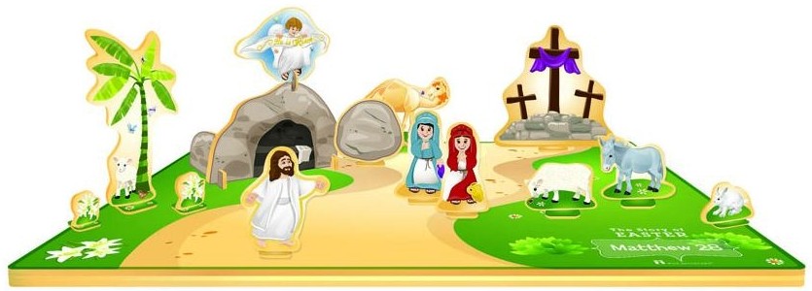
Chair of Governors

Easter Joy
Jesus came to earth, to show us how to live
How to put others first, How to love and how to give
Then he set about his work, that God sent him to do
He took our punishment on himself; He made us clean and new
He could have saved himself… Amen

