December 2022

Dear Parents and Carers,
It is hard to believe that we have already completed the first term of this school year, and what a term it has been. As you will all now know on the 18th and 19th of October the Ofsted Inspector was in school It is so wonderful that St Wilfrid’s was judged still to be a solidly
Good School. As Chair of the Governing Body, I would like to say Congratulations for the input everyone gave during the Inspection process. The Governing Body recognises that St Wilfrid’s has made huge strides since the last Inspection. So well done and now we begin the next phase of our journey together to make St Wilfrid’s an Outstanding School
The Governing Body throughout this Autumn term have been busy working in Partnership with the Senior Leadership Team in reviewing available school performance data, managing strategic decisions and focusing on the key areas of the School Development Plan. I am extremely pleased to report that the school continues to strive for perfection in all areas, under the excellent leadership of Mrs McEniff and Mrs Harkness who are fully supported by a highly committed staff team. It is clearly evident that every child is given the opportunity to succeed and reach their potential.
I would therefore like to take this opportunity to “Thank” Mrs McEniff, Mrs Harkness and all the staff at St Wilfrid’s for their work this term. Each and every one of the team works incredibly hard to ensure that all the children can achieve their best. This includes not only the Teachers and Teaching Assistants who work in the class rooms but also the Governing Body, The Admin team, Premises and Catering staff and the PTFA, who all do a fantastic job in ensuring that St Wilfrid’s can offer such great opportunities to our children. It is a whole team effort! and I think we are very lucky to have such a switched on team, who have the well being of your children at heart.
Lastly, thank you for all the support that you as Parents and Carers have shown to the school. The children will continue to achieve best where, school and home work in partnership together. Sometimes there can be challenges along the way but by working together we at St Wilfrid’s can ensure that the children continue to do as well as they possibly can.
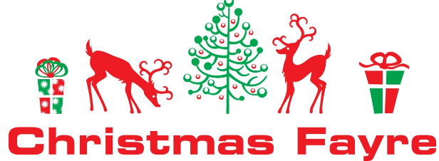
It was lovely to see so many of you supporting the PTFA school Christmas Fair and my thanks to the committee who worked so hard on the day to pull off such an amazing event and a great total was raised.
I have enjoyed both the KS1 and EYFS Nativity performances and I am looking forward with great anticipation to the KS2 carol concert on Friday. It is so lovely to see all the children participating with such enthusiasm.


To conclude I would like to take a moment to reflect on the true magnitude of Christ’s birth. Let us remind ourselves that this is the one time of the year when it is common place to find the spirit of human kindness alive and well. Let us achieve this by ensuring that we enjoy ourselves safely, but also take time to look out for our nearest and dearest to us and those less fortunate than ourselves. It is our duty to proclaim and celebrate the birth of Christ and to ensure that the real meaning of Christmas is at the forefront of our hearts and minds throughout the Christmas Season.

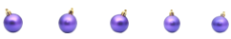
Finally, on behalf of the Governing Body, may I wish you all, and your families a very

“Happy and Holy Christmas and a Peaceful New Year.”

Best Wishes
Mrs Morrissey
Chair of Governors

