
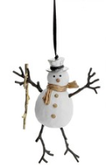

2022

Dear All

As Chair of the Governing Body, I just wanted to take this opportunity, as Christmas is almost upon us to


each and every one of you for your support particularly in the light of our recent Ofsted Inspection. As I know how hard each and every one of you worked during the term to ensure that St Wilfrid’s retained its grading of a Good School, I am so lucky to have such an amazing and hardworking team.

In whatever role you carry out within school you all strive to try and make St Wilfrid’s School the best it can be and to ensure that all the children receive an excellent education grounded in the Catholic Faith, therefore, I feel privileged to work closely with a Staff Team who show dedication, commitment and enthusiasm on a day to day basis in the hope that this education will serve all our children well in their future lives.

I do hope that each one of you has a wonderful Christmas Holiday and I look forward to seeing you all in 2023.

May I also wish you and your families a very:

“Happy and Holy Christmas and a Peaceful New Year”

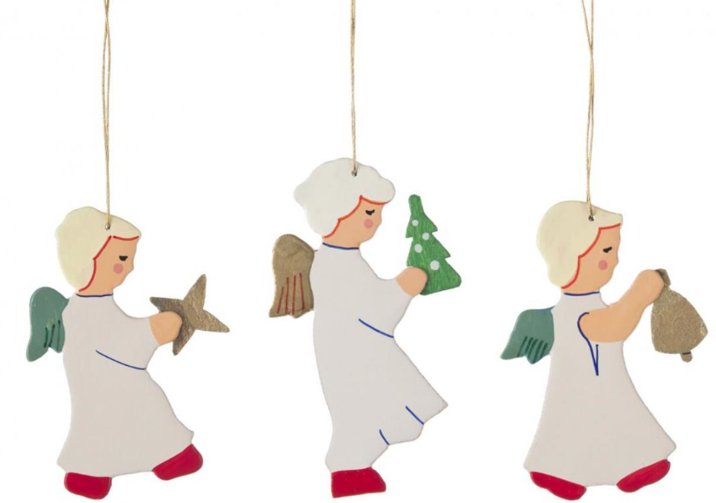
Best Wishes

Elaine

Chair of Governors

