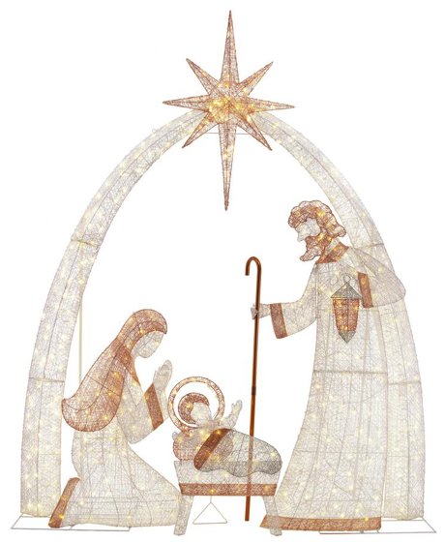

December 2022

Dear All,

Once again this term has been a challenging and busy time for us as a Governing Body, but I am sure that you will all agree a very successful one. I feel that all your support and time that you have invested in your role as a governor certainly came to fruition when Ofsted inspected our school on 18t^{th} and 19th of October and in the report as I am sure that you have all read it stated that the leadership team of the school had maintained a good quality of education and that school continued to be a Good school.

The above judgement certainly made me feel very proud of St Wilfrid’s Governing Body, as without each one of you and your commitment that you give then we as a Governing Body, would not have achieved such a successful Ofsted Inspection.

So, can I take this opportunity to “Thank” each and every one of you for all of your time, effort and support that you have given to St Wilfrid’s during this very busy term. It is very much appreciated by the whole school community.
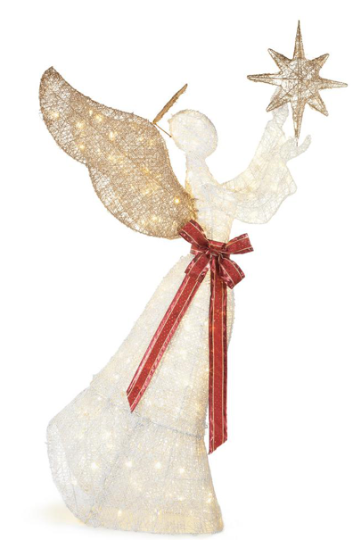
As we proclaim and celebrate the birth of Christ and to ensure that the real message of Christmas is at the forefront of our hearts and minds throughout the festive season. It is the time of year when we remind ourselves that it is common place to find the spirit of human kindness alive and well. Let us embrace this by ensuring that we take time to look out for those nearest and dearest to us and also those less fortunate than ourselves.

I would like to send my best wishes to you and your families at this special time and to wish you all

“A Very Happy and Holy Christmas and a Peaceful New Year”

With every good wish for this festive season


Elaine

Chair of Governors

